
Supervisor Release 3 Rule Designer
Outline System Specifications Document
Version 1.0

© Marlborough Stirling plc 2005
Copyright in this work is vested in Marlborough Stirling plc (Marlborough Stirling). This work may form part of a proposal by Marlborough Stirling and may not be used for any purpose other than the furtherance of such proposal. No part of this document nor the information contained herein may be reproduced, stored in a retrieval system or transmitted in any way or by any means including photocopying or recording, nor may this document or any part or parts hereof nor the information contained herein be released to any third party without the prior written consent of Marlborough Stirling, application for which should be addressed to the Company Secretary at Marlborough Stirling.

Contents
1. Introduction 8
1.1 Who Should Read This Document 8
1.2 About This Document 8
2. References and Acronyms 10
2.1 Reference Documents 10
2.2 Acronyms 11
3. Overview of Supervisor 12
3.1 Accessing Functionality Through Supervisor 12
4. Combo Groups 16
4.1 Business Purpose 16
4.2 Add/Edit Combo Box Group Dialog Controls 16
4.3 Components 17
4.4 Relationship Diagrams 17
5. French Data Support 19
5.1 Nomenclature and Examples 19
5.1.1 Nomenclature 19
5.1.1.1 Dialog Box 19
5.1.1.2 Panes 20
5.2 Supervisor UI Controls and French Data Support 20
5.3 Business Purpose 23
5.4 Multilingual Input Grid 23
5.4.1 Default Language Data 24
5.5 Relationship Diagrams 25
6. Parameter Matrix 27
6.1 Business Purpose 27
6.2 Parameter Matrix Dialog Controls 27
6.2.1 Components 28
6.2.2 Relationship Diagrams 29
7. Rule Designer 30
7.1 Business Purpose 30
7.2 Rule Designer Dialog 30
7.2.1 Rule Identification Pane 31
7.2.2 Rules Descriptor XML Context Pane 31
7.2.3 Rules Builder Pane 32
7.2.4 Rule File Operations Controls 34
7.2.5 Building Custom Rules 35
7.3 Components 35
7.4 Relationship Diagrams 35
8. Rules Manager 36
8.1 Business Purpose 36
8.1.1 Auto-Adjudication and Ingestion Services 37
8.1.2 Rules Manager Activity Diagram 37
8.1.3 Discovery Mode Sequence Diagram 39
8.1.4 Explicit Mode Sequence Diagram 39
8.2 UI Elements 40
8.3 Discovery Mode Input 40
8.3.1 XSD Schema for Discovery Mode Input 40
8.3.2 Discovery Mode Example 41
8.3.3 Applicability Category Parameter Matrix Entries 42
8.3.4 Rules Per Category 43
8.3.5 Categories and Rules 43
8.3.6 Flexibility in Rule References and the Parameter Matrix 44
8.3.7 Flexibility and Sequence Numbers 45
8.3.8 Traversing the Rule Reference 45
8.4 Discovery Mode Output 45
8.5 Explicit Mode Input 46
8.5.1 XSD Schema for Explicit Mode Input 46
8.6 Explicit Mode Output 47
8.7 Components 48
8.8 Relationship Diagrams 48
9. Rules Engine 49
9.1 Business Purpose 49
9.2 GUI Elements 49
9.3 Input 49
9.3.1 Parameter Matrix Data and Configuring the Rules Engine 49
9.3.2 Input Format 51
9.4 REQUEST Element 52
9.4.1 Attributes 53
9.4.2 Elements 53
9.5 RULES Syntax 54
9.5.1 Elements 54
9.6 RULE Syntax 54
9.6.1 Attributes 54
9.6.2 Elements 54
9.7 BYTECODE Syntax 55
9.7.1 Attributes 55
9.7.2 Elements 55
9.8 LOOP Syntax 55
9.8.1 Elements 55
9.9 P Syntax 56
9.9.1 Attributes 56
9.10 FILTER and CONDITION Syntax 56
9.10.1 Elements 56
9.11 AND Syntax 56
9.11.1 Elements 56
9.12 B Syntax 56
9.12.1 Attributes 57
9.12.2 Elements 57
9.13 E Syntax 57
9.13.1 Elements 58
9.14 OUTPUT Syntax 58
9.14.1 Elements 58
9.15 RULEREF Syntax 59
9.15.1 Attributes 59
9.16 Sample Rule Requests 59
9.16.1 Rule Request using a RULE Node 59
9.16.2 Rule Request Using a <RULEREF> Node Referencing a Rule ID 60
9.16.3 Rule Request Using a <RULEREF> Node Referencing a Parameter Matrix 60
9.16.4 Rule Request Using a <RULEREF> Node Referencing a Component Type/Rule Type 60
9.16.5 Rule Request Using a <RULEREF> Node Referencing a Combination of Rule References 60
9.17 Output 60
9.18 Components 61
9.19 Relationship Diagrams 61
RulesDescriptor.XML 62
RulesDescriptor.XML 62
Index 63
Figures List 66

Introduction
This document is the Outline Systems Specification for the Rule Designer components of the Supervisor product, release 3. Supervisor is a configuration and maintenance tool for use with Omiga. It performs the following functions:
- Reads from the Omiga database and presents the results in a set of Graphical User Interface (GUI) windows and dialog boxes
- Writes specific values to the Omiga database after edits are performed in the relevant GUI component
- Creates and clears customer and application locks
Supervisor is a client in a client-server environment. It is deployed on a workstation and is supported under Windows 2000. In order to use Supervisor you must have the following:
- A working network connection to the Omiga database server
- A user record, created in the database, with DBA-level access rights.

Who Should Read This Document
The suggested audience for this document is system administrators and testers of the configuration and maintenance functionality of this product. Before you begin working with this document, you should have a working knowledge of the underlying Omiga database structure. If you are configuring the system, you should also have a knowledge of the business processes relevant to the configuration process.

About This Document
This document describes those aspects of the Supervisor product used in managing database entries that describe the rules that govern the business processes associated with the processing of mortgage applications. Other aspects of Supervisor are described in separate volumes. See the table in Reference Documents on page 11 for information about the contents of those volumes.
This document represents a change in format for the Supervisor OSS. Previous editions described only the functionality introduced in the then-current release of the Supervisor product. For this release, the Supervisor OSS is being released as a set of volumes encompassing both new and existing functionality. There is no specific focus on new functionality.
Note: The previous paragraph notwithstanding, the new functionality introduced in Release 3 is mostly described in Supervisor Release 3 Configuration OSS and Supervisor Release 3 Task Management OSS.
The Outline Systems Specifications in general, and this volume in particular, are primarily concerned with describing the components of the user interface (UI) used in the performance of the functions described earlier in this section. These components are described in detail in a series of tables, one table per UI dialog box or list view. Where these components draw on tables in the database, or on other components of Supervisor, these tables or components are identified in the description of the individual component.
This document is divided into sections, each of which describes a specific category of functions within Supervisor. Each section contains a brief introduction and a subsection describing the business purpose filled by the category. The body of the section is the series of tables describing the UI components used by the category to enable users to interact with the category’s functions. The section concludes with a diagram representing the relationships between the Omiga database tables involved in the category.
Supervisor Release 3 Rule Designer OSS contains the following sections:
- References and Acronyms provides lists of documents and acronyms that will be useful in working with this volume.
- Overview of Supervisor is a brief introduction to Supervisor and the functionality used in working with the software.
- Combo Groups describes the UI components used in creating and maintaining the combo group type of configuration data, with specific reference to its use in building rules.
- French Data Support describes how Supervisor is used to conform to the multilingual requirements of the Omiga system.
- Parameter Matrix describes UI components used in providing a tabular representation of some types of Supervisor data.
- Rule Designer describes the UI components used in creating rules for use with the Omiga system.
- Rules Manager describes the mechanisms and methods by which access to the Rules Engine is controlled.
- Rules Engine describes how business rules are processed and used to generate appropriate output that can in turn be used in the mortgage application process.
There is a single appendix:
- RulesDescriptor.xml points to the latest version of the XML file used in creating rules.
In addition, this document contains an index and a table of figures.

References and Acronyms

Reference Documents
The following documents are part of the Omiga solution, and should be read in conjunction with this document.
Document Name | Purpose
Omiga OSS | The OSS for the Omiga product. It contains business and technical information about Omiga, including database schema information.
Supervisor OSS
Supervisor Configuration OSS | The Outline System Specification (OSS) for configuration management functions within the Supervisor solution. It describes Supervisor components for managing configuration data sets, users and security, and document generation.
Supervisor Rule Designer OSS | The OSS for the Supervisor Rule Designer. It describes Supervisor components for setting up and maintaining rules that govern the processing of mortgage applications.
Supervisor Product Factory OSS | The OSS for the Supervisor Product Factory. It describes Supervisor components used in managing mortgage products and related materials, including base lending rates.
Supervisor Task Management OSS | The OSS for task management functions within the Supervisor solution. It describes Supervisor components used for setting up and maintaining tasks that define individual business processes used in the processing of mortgage applications through Omiga.
Supervisor Deployment OSS | The OSS for the installation and maintenance of the Supervisor solution. It describes how to install Supervisor and configure the workstation on which it is being installed. It also describes how to configure the database so users can log in to the database using Supervisor. Finally, it contains information on how to maintain Supervisor.
Supervisor User Manual
Supervisor Configuration User Manual | The user manual for configuration management functionality in the Supervisor product. It contains task-oriented material (procedures) designed to help users work with configuration sets and user access in Supervisor.
Supervisor Rule Designer User Manual | The user manual for rules and rule-related functionality in the Supervisor product. It contains procedures for creating and managing rules that govern mortgage processing, and for using configuration data in the creation of rules.
Supervisor Product Factory User Manual | The user manual for mortgage-product functionality in the Supervisor product. It contains procedures for creating and maintaining records describing mortgage product and related materials.
Supervisor Task Management User Manual | The user manual for task-management functionality in the Supervisor product. It contains procedures for creating and maintaining tasks that define business processes used with Omiga.
While these documents describe all functionality currently provided in Supervisor, if you are looking specifically for functionality introduced in previous releases, you can also find refer to the Release 1 and Release 2 editions of the Supervisor OSS document.

Acronyms
The following acronyms are used in this document.
Acronym | Control Type and Description
ADS | Active Directory Server (Microsoft Windows 2000)
OSS | Outline System Specification
XML | Extensible Mark-up Language
GUI | Graphical User Interface
UI | User Interface (this is the preferred acronym)

Overview of Supervisor
Supervisor is a thick client that is installed on a workstation inside a corporate LAN. It connects directly to the Omiga database and allows you to create, update, or delete certain database entries. Its business purpose is to allow you to configure Omiga to work with your business rules.
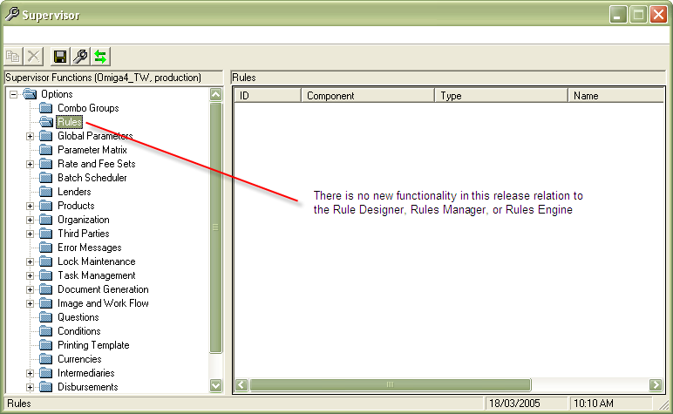
Figure 1: Supervisor Main Window, highlighting the category described in this book.
There is a large range of functionality available in Supervisor. Most functionality is contained in categories that are displayed in a navigation tree viewed from the Supervisor window.

Accessing Functionality Through Supervisor
The following categories are accessible using the Supervisor navigation tree:
- Base Rates
- Combo Groups
- Conditions
- Disbursements
- Document Generation
- Error Messages
- French Data Support
- Image and Work Flow
- Lenders
- Mortgage Products
- Organization
- Parameter Matrix
- Rules Designer
Note: The above list is ordered alphabetically. Categories are displayed in the navigation tree in a different order.
The following categories are not accessible using Supervisor:
- Product Factory
- Rules Manager
- Rules Engine
These categories derive their input from the information contained in Supervisor, but do not have any external GUI interface.
Configuration management is accessible through the File menu in Supervisor, but does not have a UI category associated with it.
Categories are contained in nodes of the Supervisor UI tree view, and are represented by folder or subfolder icons in the left-hand pane. If a node has an expand button (+) beside it, that node contains subfolders. To view them, click the expand button.
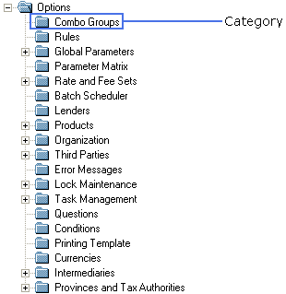
Figure 2: Supervisor Categories.
To view the contents of a category
- Do one of the following:
- If the category has an expand button, click the button to expand the category, and then click a category folder to select it.
- If the category has no expand button, cluck the category folder to select it.
Entries for the category are displayed in the right-hand pane.
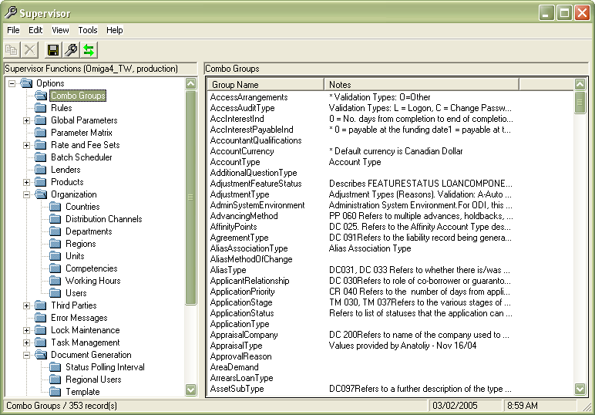
Figure 3: Supervisor Entries
To access a record in a category
- View the contents of the category, as described previously.
- In the right-hand pane, double-click on the entry whose record you want to view.
- Combo Groups
- Rules Designer
The corresponding dialog box appears. This example shows a combo group dialog.
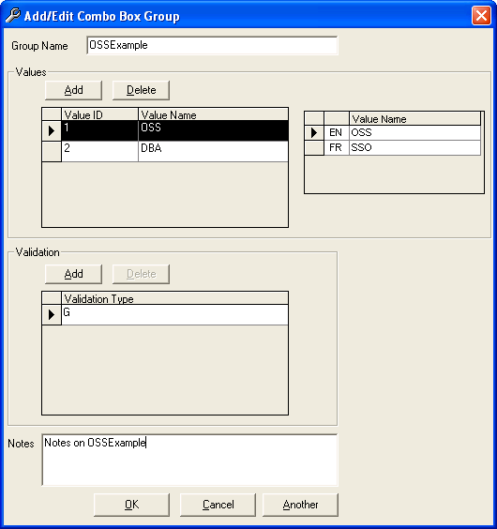
To access French data support, see French Data Support on page 20.
Note: The Parameter Matrix is an exception to this general rule. To view the contents of the Parameter Matrix, double-click the Parameter Matrix folder in the navigation tree. You can also open the matrix by right-clicking the folder and choosing Edit.
You create new records in Supervisor following one general procedure. Again, the Parameter Matrix is an exception. See the note above.
To create a record in Supervisor
- Right-click the category in which you want to create the record.
- From the menu that appears, choose Add New.
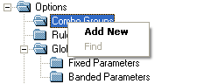
- Follow the specific procedures as described in the appropriate volume of Supervisor User Manual.
Warning: Supervisor may show categories that are not described in this or previous versions of the Supervisor OSS. You should not attempt to use categories that have not been documented. Unpredictable behaviour may result, with possible loss of data.

Combo Groups
Combo groups are uniquely defined by a group name. Each group name contains one or more sets of value ID/name pairs. Each of these pairs can have one or more validation types associated with them. A value name can be entered in either English or French.

Business Purpose
Combo groups are named this way because they are an internal representation of the similarly named GUI element in Microsoft Windows™. However, the data contained in a combo group is not necessarily presented in the Omiga UI, and can be manipulated completely internally. For example, data contained in combo groups can be accessed by the Rules Designer and used to build rules.

Add/Edit Combo Box Group Dialog Controls
The Add/Edit Combo Box Group dialog allows the addition and editing of values within a combo group. The following table describes the controls in this dialog.
Figure 4: Add/Edit Combo Box Group dialog.
Control Label | Control Type and Description
Another | Command button. When clicked, saves the current combo group and opens a new combo group with no data entered.
Cancel | Command button. When clicked, closes the dialog without saving any changes.
EN/FR | Text box. Allows entry of multilingual text. The value in EN is displayed in Supervisor if you are viewing English text. The value in FR is displayed in Supervisor if you are viewing French text. See page 20 for more details.
Group Name | Text box. Allows entry of a unique identifier for this combo box group. Box is read-only in edit mode.
Notes | Text box. Allows entry of any notes about this combo group. These are used for internal reference only and are never displayed in the Omiga UI.
OK | Command button. When clicked, saves all valid changes to the current combo group and closes the dialog.
Validation Type | Each paired Value ID/Value Name can have one or more entries in this element. Data in this element can be used to internally group the paired Value ID/Value Name elements. For example, Mr., M., and Herr are the titles used to address males in English, French, and German. If you had a combo group with Value Names of Mr., M., and Herr, then you can use a validation type of M for each of these to indicate these are all titles which are applied to males.
Value ID | Text box. Allows entry of an integer number providing an internal representation of the value displayed in Value Name.
Value Name | Text box. Allows entry of the value that will be displayed in the Omiga UI.
Add | Command button. When clicked, allows adding of a validation type to the selected value name.
Delete | Command button. When clicked, deletes the selected validation type. Button is disabled unless a validation type is selected.

Components
The combo box groups use the following components:
- omspvComboGroups.dll: This component renders the combo box groups GUI and creates, updates, and deletes the stored combo box group data in the Omiga database.

Relationship Diagrams
The following diagram illustrates the relationships between database tables used with combo groups:
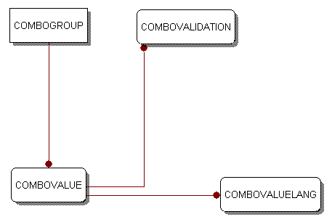
Figure 5: Combo Box Group Database Table Relationships

French Data Support
A shared VB GUI component is used in Supervisor to accept French language data. Data entered in the GUI using this component is stored in a separate database table. The link between the stored French language data and the corresponding control is done through a primary key/foreign key relationship in the appropriate tables.

Nomenclature and Examples
This section describes the nomenclature used to describe UI elements, and shows examples of the UI elements discussed in Supervisor UI Controls and French Data Support on page 21.

Nomenclature
The nomenclature used here corresponds to the recommendations in the Microsoft Manual of Style for Technical Publications, version 3.0.

Dialog Box
The Add/Edit dialog boxes are accessed by:
- double-clicking on an existing entry in that Supervisor category
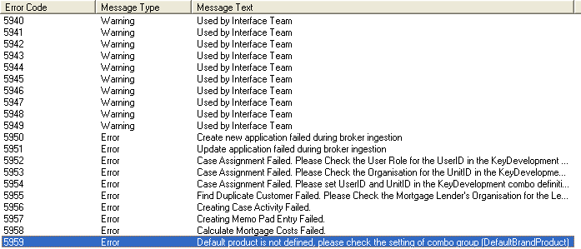
- right-clicking on a main category folder and selecting Add New.
A sample Add/Edit dialog box is:
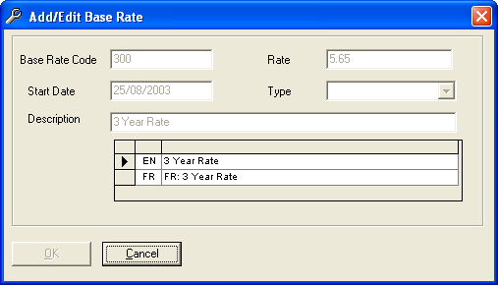

Panes
The main Supervisor pane shows all entries for a given Supervisor category. They appear when you click on a Supervisor category.

English Values in a Pane

French Values in a Pane

Supervisor UI Controls and French Data Support
French data support is present in the following areas of Supervisor.
Screen/Feature | Area of French Data Support
Activities Add/Edit dialog box | One multilingual control to support Activity Name. All values in list boxes will be displayed in English or French, based on the current session language.
Activities pane | Activity will be displayed in English or French, based on the current session language.
Admin Fee Set Add/Edit dialog box | The values for Type of Application and Location will be displayed in English or French, based on the current session language.
Admin Fee Set pane | The values for Type of Application and Location will be displayed in English or French, based on the current session language.
Appraisal Fee Set Add/Edit dialog box | The values for Appraisal Type and Location will be displayed in English or French, based on the current session language.
Appraisal Fee Set pane | The values for Appraisal Type and Location will be displayed in English or French, based on the current session language.
Base Rate pane | Description will be displayed in English or French, based on the current session language.
Base Rate Sets Add/Edit dialog box | One multilingual control to support the Description text box.
Combo Box Group Add/Edit dialog box | One multilingual control to support the Value Name text box.
Conditions Add/Edit dialog box | One multilingual control to support Condition Name and one multilingual control to support Description. All values in drop-down list boxes will be displayed in English or French, based on the current session language.
Conditions pane | Task Name will be displayed in English or French, based on the current session language.
Country Add/Edit dialog box | Country Name will be displayed in English or French, based on the current session language.
Department Add/Edit dialog box | One multilingual control to support Department Name. All values in drop-down list boxes will be displayed in English or French, based on the current session language.
Departments pane | Department Name will be displayed in English or French, based on the current session language.
Distribution Channels dialog box | One multilingual control to support Channel Name.  The value for the drop-down list box  - Non WorkingType  and the value in the cell  - Weekday  will be displayed in English or French, based on the current session language.
Distribution Channels pane | Channel Name will be displayed in English or French, based on the current session language.
Error Messages screen | One multilingual control to support Message Text.
Find Products screen | Searching using By Product Name is done using the current session language.
Intermediaries Add/Edit dialog box | All values in drop-down list boxes will be displayed in English or French, based on the current session language. Note that the company/individual name is not multilingual.
Lender Details dialog box: Additional Parameters tab | The values for the drop-down list boxes  - Accrued Interest Indicator  - Accrued Interest Payable  - Accrued Interest Rounding Direction  - First Payment Due Date  - Accounting Start Month  - Interest Charged Indicator  - Interest Change Indicator  - Part & Part Rounding  - Monthly Payment Indicator  - Payment Rounding Direction  - Interest Calc. Rounding Direction  - Position in Month  will be displayed in English or French, based on the current session language.
Lender Details dialog box: Brands tab | All brands will be displayed in English or French, based on the current session language.
Lender Details dialog box: Contact Details tab | The values for the drop-down list boxes  - Province/Territory  - Country  - Contact Type  - Contact Title  - Type  will be displayed in English or French, based on the current session language.
Lender Details dialog box: Lender Details tab | One multilingual control to support the Lender Name text box. The values for the drop-down list boxes  - Organisation Type  - Name & Address Type  - Preferred Life Insurer  will be displayed in English or French, based on the current session language.
Lenders pane | Description will be displayed in English or French, based on the current session language.
Main Supervisor menu | You can switch the current session language by selecting View > [Language].
Mortgage Products pane | Product Name will be displayed in English or French, based on the current session language.
Product Details dialog box: All tabs | All values in drop-down list boxes and list boxes will be displayed in English or French, based on the current session language.
Product Details dialog box: Product Details tab | One multilingual control to support Mortgage Product Name.
Province Add/Edit dialog box | The values for the drop-down list box  - Province Territory  will be displayed in English or French, based on the current session language.
Province pane | Territory Name will be displayed in English or French, based on the current session language.
Stage Task Add/Edit dialog box | The values for the drop-down list boxes  - Task  - Authority Level  will be displayed in English or French, based on the current session language.
Stages Add/Edit dialog box | One multilingual control to support Stage Name. All values in drop-down list boxes will be displayed in English or French, based on the current session language.
Stages pane | Stage Name will be displayed in English or French, based on the current session language.
Task Add/Edit dialog box | One multilingual control to support Task Name. All values in drop-down list boxes will be displayed in English or French, based on the current session language.
Tasks pane | Task Name will be displayed in English or French, based on the current session language.
Unit Add/Edit dialog box | One multilingual control to support Unit Name. All values in drop-down list boxes will be displayed in English or French, based on the current session language.
Units pane | Unit Name will be displayed in English or French, based on the current session language.

Business Purpose
For Canada, the ability to work with text in either official language is required.

Multilingual Input Grid
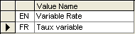
Figure 6: Multilingual Input Element
This multilingual UI grid control allows you to enter both English and French data. There are two cells where data is entered. English data is entered in the EN cell, while French data is entered in the FR cell.

Default Language Data
If you enter an English value and do not enter anything in the FR cell, when you exit the dialog box, a message box will appear asking you if you want to enter default language values.
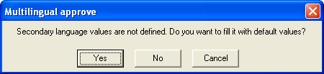
Figure 7: Multilingual Approve Message Box
If you click Yes, then the data in the FR cell will be automatically set to the same value as that entered in the EN cell, with the string FR: appended to the beginning.
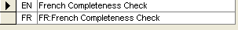
Figure 8: Default French Language Values
If you enter a French value and do not enter anything in the EN cell, when you exit the dialog box, a message box will appear asking you if you want to enter default language values.
If you click Yes, then the data in the EN cell will be automatically set to the same value as that entered in the FR cell, with the string EN: appended to the beginning.
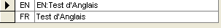
Figure 9: Default English Language Values

Relationship Diagrams
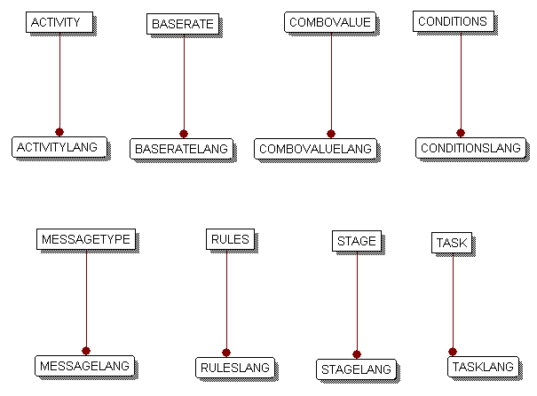
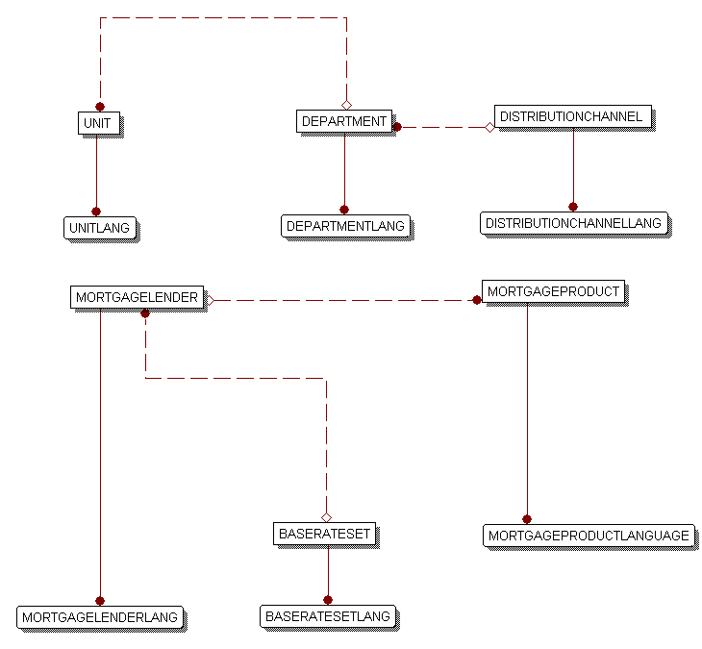
Figure 10: Language Database Table Relationships

Parameter Matrix
Parameter matrices contain sets of the following components:
Parameter Matrix Component | Description
Name | Name of the Parameter Matrix entry.
Key1, Key2,…,Key5 | One to five keys associated with a Parameter Matrix entry.
Value | The value associated with the entry and set of keys.
Each Parameter Matrix entry for a given Name must contain a unique set of keys. Duplicate sets of keys are not permitted. Duplicate values are permitted for the Value.

Business Purpose
Parameter matrices are used where data is best contained in a tabular format. They are used for data which has a range of values.
The Parameter Matrix is also used to configure the order in which rules will be run by the ingestion and auto-adjudication services. The Rules Engine looks at specific Parameter Matrix entries to determine which rules are going to be run, and in what order. For more information on this, see Parameter Matrix Data and Configuring the Rules Engine on page 52 and the Rule Engine volume of Supervisor User Manual.

Parameter Matrix Dialog Controls
The Parameter Matrix dialog appears when you double-click the Parameter Matrix folder in Supervisor. The following table describes the controls on this dialog.
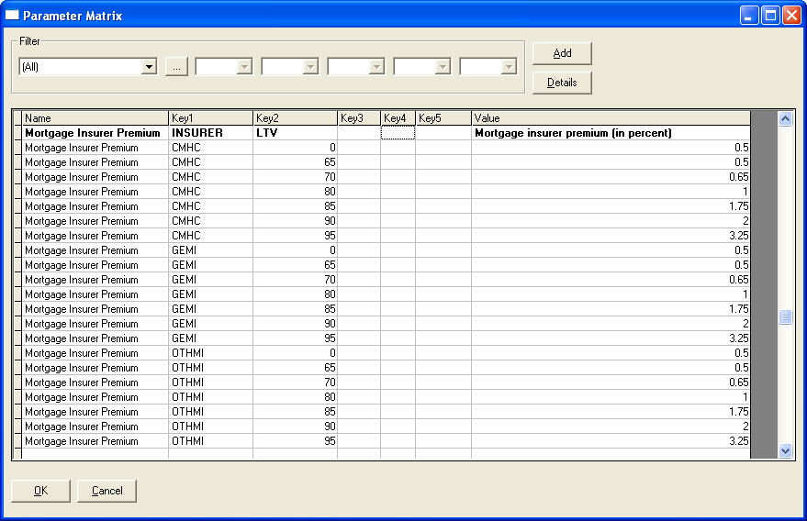
Figure 11: Parameter Matrix dialog.
Control Label | Control Type and Description
Cancel | Command button. When clicked, closes the dialog without saving any changes.
Filter | Group box. Contains a series of drop-down list boxes containing the names of all Parameter Matrix entries. You can select an entry here and restrict the display to showing only this entry. You select All to display all entries. See the Supervisor User Manual for more information on using filters in the Parameter Matrix.
Key1, Key2, Key3, Key4, Key5 | Column label. Displays keys associated with each Parameter Matrix entry.
Name | Column label. Displays the descriptive name for this Parameter Matrix entry.
OK | Command button. When clicked, writes any valid changes to the database and closes the dialog.
Value | Column label. Displays value associated with the unique set of keys.

Components
The Parameter Matrix uses the following components:
omspvPMatrix.dll: This component renders the Parameter Matrix GUI and creates, updates, and deletes the stored Parameter Matrix entries in the Omiga database.

Relationship Diagrams
The following diagram shows the relationship between tables for Parameter Matrix entries.
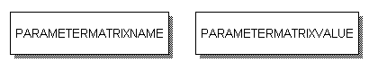
Figure 12: Parameter Matrix Database Table Relationships
PARAMETERMATRIXNAME contains the names of all parameters in the database. PARAMETERMATRIXVALUE contains all values in the Parameter Matrix.

Rule Designer
The Rule Designer is an integrated set of functions in Supervisor. These functions allow you to create rules for use with Omiga through a GUI. The Rules Engine is the combination of VB components and XML messages that interprets and runs the rules built by the rules designer.

Business Purpose
Rules are used within Omiga to help process mortgage applications. They can be grouped into areas of functionality. Example functional areas are:
- Completeness Check Rules: These rules are designed to examine mortgage application data and verify whether mandatory data is present.
- Auto-adjudication Rules: These rules are designed to examine the mortgage application data and determine whether it can be passed on automatically to the next phase of the application process, or whether the current application needs to be referred to an underwriter for further analysis and decisions.

Rule Designer Dialog
The Rule Designer has a graphic user interface. See the Supervisor User Manual for more information on how to build rules using this interface.
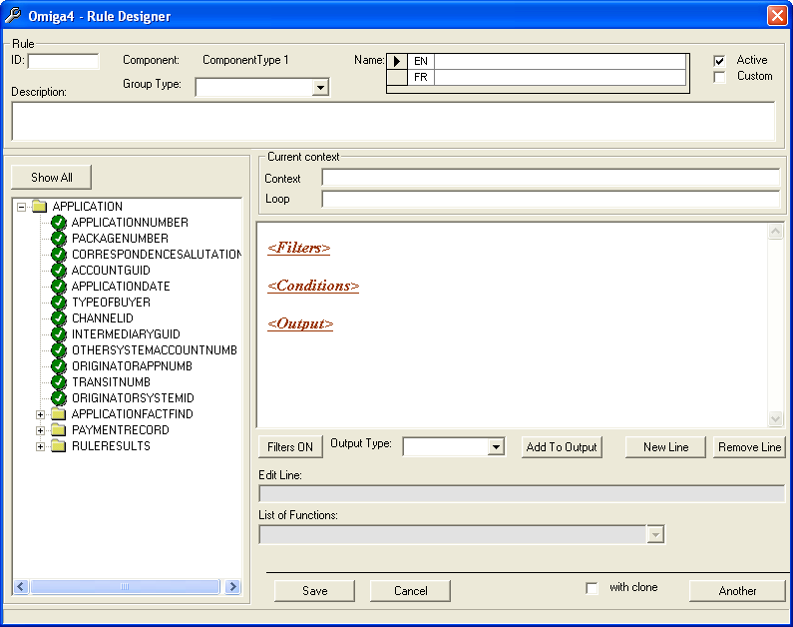
Figure 13: Rule Designer dialog.
This dialog contains the following elements:

Rule Identification Pane
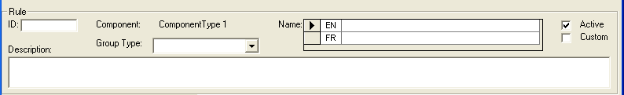
Figure 14: Rule Designer Identification Pane
Control Label | Control Type and Description
Active | Check-box. If selected, this rule is active and will be processed by the Rules Engine. If cleared, this rule is inactive and will not be processed by the Rules Engine.
Custom | Check-box If selected, this rule is not processed by the native Rules Engine, but is processed by a custom engine. If cleared, this rule is processed by the native Rules Engine (if it is an active rule).
Description | Text box. Allows entry of a brief description of the rule. This is for internal use only and does not appear in any rule output.
Group Type | Drop-down list box. Allows selection of a grouping category for the rule.
ID | Text box. Allows entry of a unique identifier code for the rule. Can contain alphanumeric characters and the characters '.', '_', and '-'.
Name | Text box. Allows entry of the name for this rule. Uses the French language control described on page 20.

Rules Descriptor XML Context Pane
This pane exposes the contents of the file RulesDescriptor.xml in a tree format. The file RulesDescriptor.xml is found in the directory where Supervisor was installed.
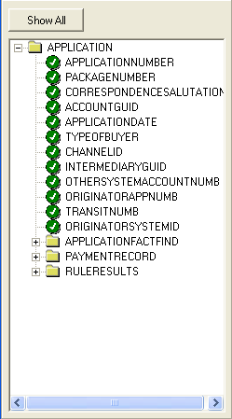
Figure 15: Rule Designer XML Context Pane.
The Show All button toggles the display of available contexts when building a rule.

Rules Builder Pane
This pane contains the elements that allow you to build a rule using the interface.
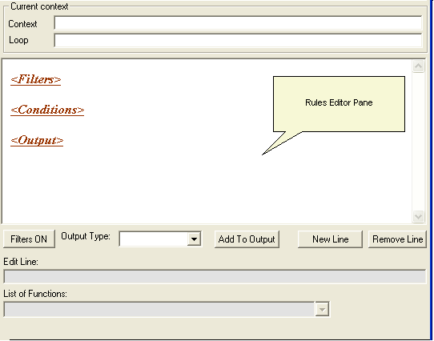
Figure 16: Rules Designer Rules Builder Pane
Control Label | Control Type and Description
Add To Output | Command button. When clicked, adds the selected output in Output Type to the rule editor pane.
Context | Text box. Displays the current XML context for the rule. The context determines what contexts and attributes are available in the rule.
Edit Line | Text box. Allows entry of the contents of the rule.
Filters ON/Filters OFF | Command button. Acts as a toggle for filters in the rule. If this button is in the Filters ON state, then all filters are available and will be used when this rule is evaluated by the Rules Engine. If this button is in the Filters OFF state, then all filters are unavailable and will be ignored when this rule is evaluated by the Rules Engine.
List of Functions | Drop-down list box. Allows selection of functions recognized by the Rules Engine. These functions are available for use in filters, conditions, and outputs.
Loop | Text box. Allows entry of the loop for the rule. By using a loop, the rule will generate multiple outputs each time it evaluates.
New Line | Command button. When clicked, adds a new blank line in the rules editor pane.
Output Type | Drop-down list box. Allows selection of an output for this rule if the rule evaluates to TRUE after being evaluated by the Rules Engine.
Remove Line | Command button. When clicked, removes the currently selected line in the rules editor pane.
Rules Editor Pane | Text box. This pane contains all the Filters, Conditions, and Output for the rule.

Rule File Operations Controls
These controls allow you to save rules. You can also clone rules, and create a new blank rule without needing to exit the Rules Designer.
Figure 17: Rules Designer File Operations Controls
Control Label | Control Type and Descriptions
Another | Command button. When clicked, saves the current rule and clears the dialog, allowing creation of a new rule.
Cancel | Command button. When clicked, closes the current rule without saving any changes.
Save | Command button. When clicked, saves the current rule and closes the dialog.
with clone | Check box. Selecting this and clicking Another opens a new rule with all the same properties as the current rule.

Building Custom Rules
In addition to rules created in the Rule Designer, you can create custom rules by creating a new COM+ component and adding the rule to it. The syntax for custom rules in Visual Basic 6.0 for a rule with an ID of AA001 is:
Select Case strRuleID
Case "AA001": RunRuleAA001 vxmlRequestNode, vxmlResponseNode
After compiling the DLL, the name of the DLL and the rules group it belongs to must be entered in the Parameter Matrix.
For more information on building custom rules, see the Rule Designer volume of the Supervisor User Manual.

Components
The Rules Designer uses the following components:
omspvRuleDesigner.dll: This component renders the Rules Designer GUI and creates, updates, and deletes the stored rules in the Omiga database.

Relationship Diagrams
The following diagram shows the relationship between tables for the Rules Designer.
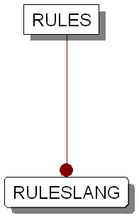
Figure 18: Rules Designer Database Table Relationships

Rules Manager
The Rules Manager service is the entry point for any access to the Rules Engine. It processes incoming requests coming from either the Omiga ingestion service or an external system. All incoming requests will be evaluated and used to call the Rules Engine.
Before making any calls to the Rules Manager, the following conditions must be met:
- Configuration data for each component and rule required during execution is complete
- The data schema being used with the rules set must be the same when multiple component types are specified in the rules request.
Note: These conditions apply to both the Discovery and Explicit modes of calling the Rules Manager service. (See below.)
Business rules stored in Omiga can be accessed in one of two ways.
- Discovery (Implicit) Mode
- Explicit Mode
In Discovery mode, the Rules Manager loads a predefined Parameter Matrix which defines the categories and applicability categories that will be used when running the rules. This Parameter Matrix is defined in the XML input for the Rules Manager. This set of categories and applicability categories is then passed to the Rules Engine.
A category is a grouping of business rules and other categories. An applicability category is a set of rules that determines when the associated business category should be run (based on the XML input). For any given applicability category, if any of the rules in that applicability category scores 1, then the set of business rules associated with that applicability category will be run.
In Explicit mode, the XML input sent to the Rules Manager explicitly specifies the combination of component type, rule, and category to be run. If multiple component types or multiple business categories and business rules are passed by this method, they must all share the same rule designer XML schema file (RulesDescriptor.xml, for example).
The Rules Manager can also access data from the mortgage application and pass that to the Rules Engine along with the rules request. See Components on page 51.

Business Purpose
The Rules Manager controls the access to the Rules Engine by allowing only a single point of entrance.
The following process diagrams show how the Rules Manager interacts with other components to invoke the Rules Engine.

Auto-Adjudication and Ingestion Services
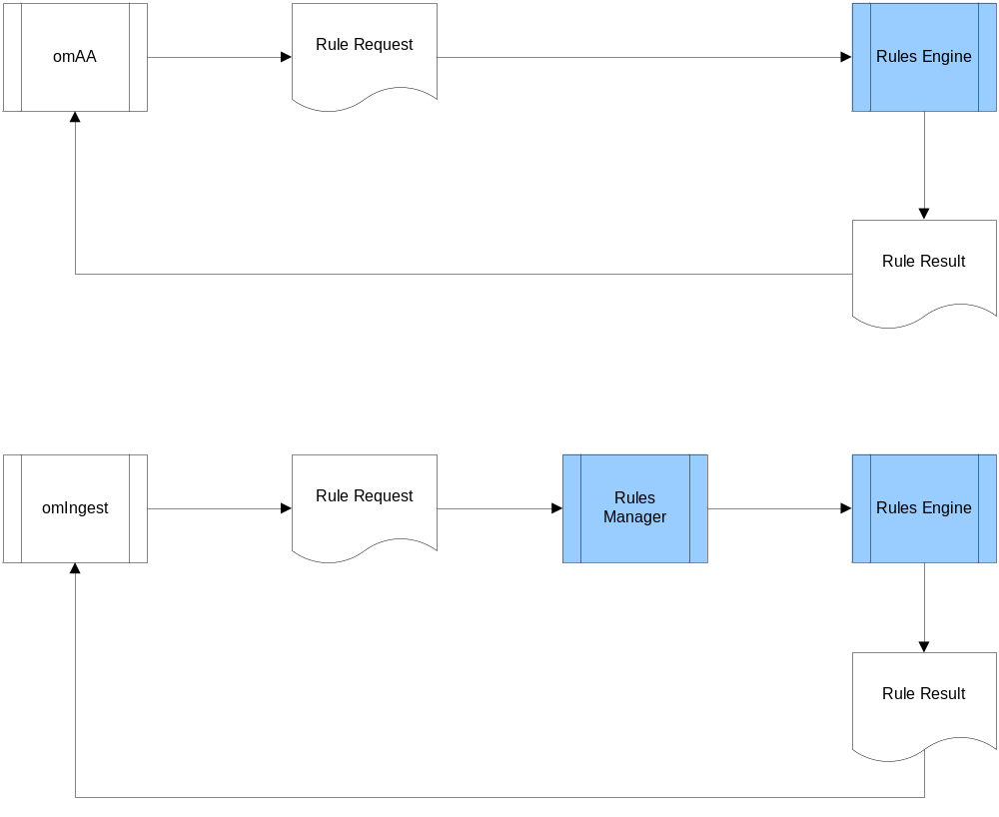
Figure 19: Rules Manager and Services
The auto-adjudication service bypasses the Rules Manager and calls the Rules Engine directly. The ingestion service passes requests through the Rules Manager.

Rules Manager Activity Diagram
The following diagram shows the sequence of Rules Manager events.
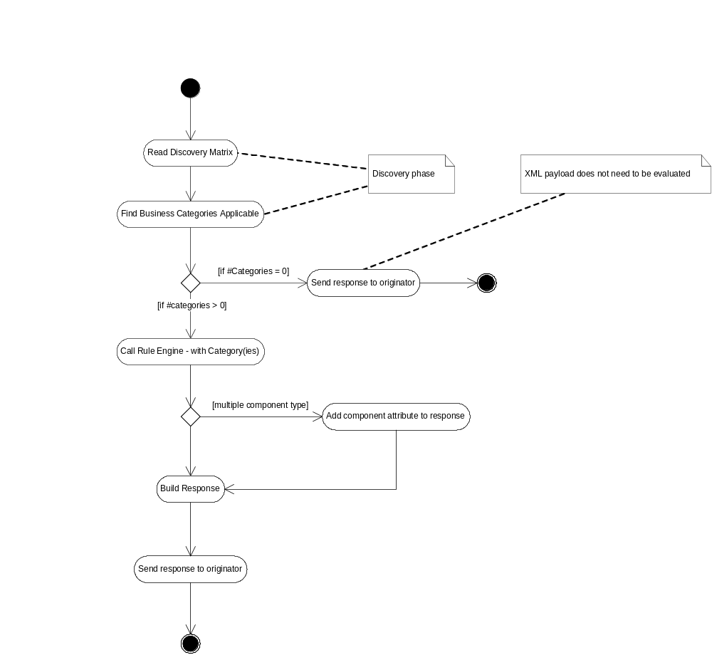
Figure 20: Rules Manager Activity Diagram

Discovery Mode Sequence Diagram
The following diagram shows the sequence of events in Discovery mode.
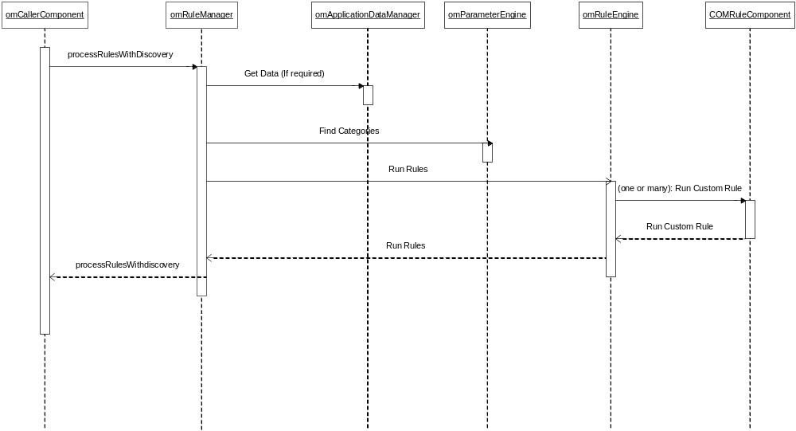
Figure 21: Discovery Mode Sequence Diagram

Explicit Mode Sequence Diagram
The following diagram shows the sequence of events in Discovery mode.
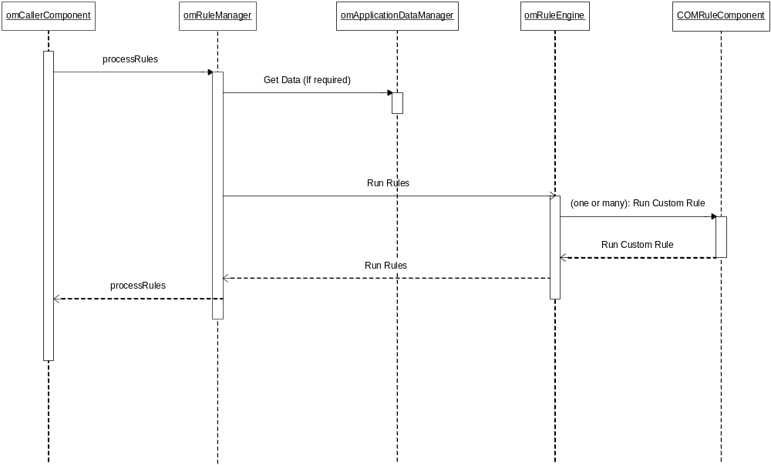
Figure 22: Explicit Mode Sequence Diagram

UI Elements
There are no UI elements in the Rules Manager. There are two GUIs associated with it, the GUI for the Parameter Matrix (see Parameter Matrix on page 29) and the GUI for the Rules Designer (see Rule Designer on page 32).

Discovery Mode Input
Input to the Rules Manager in Discovery mode is in the form of an XML data file. This data contains the mortgage application data and the Parameter Matrix parameters containing the applicability category and rules data .

XSD Schema for Discovery Mode Input
<?xml version="1.0" encoding="UTF-8"?>
<xs:schema xmlns:xs="http://www.w3.org/2001/XMLSchema" elementFormDefault="qualified">
<xs:element name="RULEREF">
<xs:annotation>
<xs:documentation>Contains rule references by Parameter Matrix Component Name</xs:documentation>
</xs:annotation>
<xs:complexType>
<xs:attribute name="OPERATION" type="xs:string" use="required"/>
</xs:complexType>
</xs:element>
<xs:element name="REQUEST">
<xs:complexType>
<xs:sequence>
<xs:element name="DATA">
<xs:annotation>
<xs:documentation>Common in ALL categories and rules passed</xs:documentation>
</xs:annotation>
</xs:element>
<xs:element ref="RULES"/>
</xs:sequence>
<xs:attribute name="outputGroup" type="xs:boolean" use="optional"/>
</xs:complexType>
</xs:element>
<xs:element name="RULE">
<xs:annotation>
<xs:documentation>Contains rule byte code inside of node</xs:documentation>
</xs:annotation>
<xs:complexType>
<xs:attribute name="ruleID" type="xs:string" use="required"/>
</xs:complexType>
</xs:element>
<xs:element name="RULES">
<xs:annotation>
<xs:documentation>Contains list of rules or rule references</xs:documentation>
</xs:annotation>
<xs:complexType>
<xs:sequence>
<xs:element ref="RULEREF" maxOccurs="unbounded"/>
</xs:sequence>
<xs:attribute name="componentType" type="xs:string"/>
</xs:complexType>
</xs:element>
</xs:schema>
An example request using this schema is shown below. The contents of the mortgage application is abstracted by the string Application XML Payload.
discovery_ruletypeautomatic_adjudication_ruletype
The COMPONENTNAME attribute in the RULEREF elements contains the name of the parameter matrices containing the applicability categories.

Discovery Mode Example
A Parameter Matrix entry with the name discovery_ruletype has been created.
NAME | KEY1 | VALUE
discovery_ruletype | AMLapplicableBR | AML
discovery_ruletype | ADJapplicableBR | ADJ
discovery_ruletype | DUEapplicableBR | DUE
discovery_ruletype | MKTapplicableBR | MKT
discovery_ruletype | Null | SOL
Each of the KEY1 values in this Parameter Matrix correspond to the applicability category. They are found in a different Parameter Matrix entry, with the name of that Parameter Matrix entry being the same as the KEY1 value. The Rules Manager will pass along the name of this applicability category to the Rules Engine, which in turn will evaluate all the rules and categories found there.
If any of those rules return a score of 1, then the entry in VALUE will be passed to the Rules Engine. This entry represents the rules for the applicability category represented in KEY1. The exception is if KEY1 is an empty value. In this case, the entry in VALUE will always be passed to the Rules Engine for further processing. In the above example, SOL will always be passed to the Rules Engine, so the set of rules contained in the Parameter Matrix SOL will always be processed by the Rules Engine.

Applicability Category Parameter Matrix Entries
The following tables correspond to the entries in KEY1 of the Parameter Matrix discovery_ruletype. They are the individual applicability categories for discovery_ruletype. Each of the rules or categories in VALUE will be evaluated to see if any return a score of 1.
NAME | KEY1 | KEY2 | VALUE
AMLapplicableBR | 1 | 0 | ApplicableAMLBR2
AMLapplicableBR | 2 | 0 | ApplicableAMLBR3
AMLapplicableBR | 3 | 0 | ApplicableAMLBR4

NAME | KEY1 | KEY2 | VALUE
ADJapplicableBR | 1 | 0 | ApplicableADJCat1
ADJapplicableBR | 2 | 0 | ApplicableADJBR1
ADJapplicableBR | 3 | 0 | ApplicableADJCat2

NAME | KEY1 | KEY2 | VALUE
MKTapplicableBR | 1 | 0 | ApplicableMKTCat5
MKTapplicableBR | 2 | 0 | ApplicableMKTCat7
MKTapplicableBR | 3 | 0 | ApplicableMKTCat9

Rules Per Category
NAME | KEY1 | KEY2 | VALUE
AML | 1 | 0 | Rule100
AML | 2 | 1 | Cat6
AML | 3 | 1 | Cat1

NAME | KEY1 | KEY2 | VALUE
ADJ | 1 | 1 | Cat4
ADJ | 2 | 0 | Rule200
ADJ | 3 | 1 | Cat1

NAME | KEY1 | KEY2 | VALUE
MKT | 1 | 1 | Cat2
MKT | 2 | 1 | Cat3
MKT | 3 | 1 | Cat4

Categories and Rules
If you want to apply multiple rules in a single rules request, you can create a Parameter Matrix to contain your rules. The Parameter Matrix is created using the Supervisor UI. The Parameter Matrix created can contain rule categories as well as individual rule IDs.
For example, say you want to create a rule Parameter Matrix with the following structure:
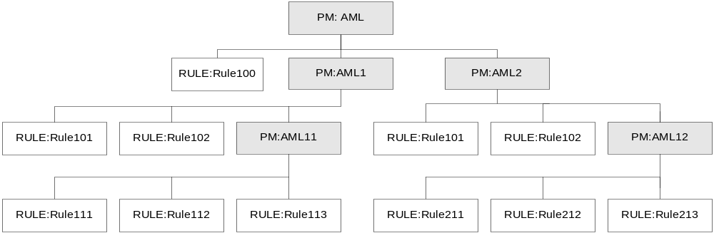I
Figure 23: Categories and Rules Example
Sub-categories and rules are defined by using a combination of keys and key values. To create multiple categories and sub-categories, as shown in the figure above, you create the top category (AML) and the two sub-categories (AML1 and AML2). You also create a rule Rule100 in the top AML category.
Then, you create two new categories for AML1 and AML2, and create their respective sub-categories AML11 and AML12. You also create four rules, two in the category AML1, and two in the category AML2.
Finally, you create two new categories for AML11 and AML12. You also create six rules, three in the category AML11, and three in the category AML12.
When you create a rules reference using a Parameter Matrix, you also configure in what sequence the rules and sub-categories will be processed. When you pass the Parameter Matrix to the Rules Engine in a rule reference, every rule will be processed in the specific order you have entered them in the Parameter Matrix.
A category is distinguished from a rule by the value you enter in Key2 in the Parameter Matrix. If you enter a value of 0, the Parameter Matrix data is treated like a rule. If you enter a value of 1, the Parameter Matrix data is treated like a category.
Parameter Matrix Field Name | Description
Name | Rule Engine category which applies to the rules or rule categories in this Parameter Matrix entry
Key1 | Sequence number
Key2 | 0 — This Parameter Matrix entry is a Rule name  1 — This Parameter Matrix entry is a Rule Engine category name
Value | Rule name or Rule Engine category name

Flexibility in Rule References and the Parameter Matrix
In the above example, each of the sub-categories can be used as a rule reference when you are building rules. For example, if you used the category of AML1 as the rule reference, then the Rules Engine would treat AML1 as the main category and AML11 as the sub-category.

Flexibility and Sequence Numbers
The order in which the rules and the sub-categories are processed depend on the sequence number entered for each parameter. For example, using the AML category as an example:
Rule or Category | Sequence Number
Rule100 | 1
AML1 | 2
The Rules Engine evaluates Rule100 first. Then the Rules Engine evaluates the sub-category AML1. The order in which the sub-categories and rules of AML1 are evaluated is determined in the separate Parameter Matrix data for AML1.
Rule or Category | Sequence Number
AML1 | 1
Rule100 | 2
The Rules Engine evaluates the sub-category AML1 first. The order in which the sub-categories and rules of AML1 are evaluated is determined in the separate Parameter Matrix data for AML1. Then the Rules Engine evaluates Rule100.

Traversing the Rule Reference
The Rules Engine will always return to the level it originated from until all rules at that level have been evaluated, and all sub-categories from that level have been traversed. For example, a portion of the above Parameter Matrix has been configured as shown below:
Name | Key1 | Key2 | Value
AML1 | 1 | 1 | AML11
AML1 | 2 | 0 | Rule101
AML1 | 3 | 0 | Rule102

Name | Key1 | Key2 | Value
AML11 | 1 | 0 | Rule111
AML11 | 2 | 0 | Rule112
AML11 | 3 | 0 | Rule113
The Rules Engine is passed AML1 as the rule reference for this Parameter Matrix. The Rules Engine goes to the sub-category AML11 first (as it is first in the sequence number, as determined by Key1), and begins processing there. In AML11, the Rules Engine processes (in order) Rule111, Rule112, and Rule113. Since the Rules Engine has not processed every entry in AML1, it returns there and goes to the entry with sequence number 2, which is Rule101. The Rules Engine processes (in order) Rule101 and Rule102, then stops processing for this particular rule reference.

Discovery Mode Output
The output from the Rules Manager when using Discovery mode is an XML-formatted message containing:
- Categories and rules recovered from the sweep through the relevant Parameter Matrix data (if any exist)
- Mortgage application data (if required)

Explicit Mode Input
Input to the Rules Manager in Explicit mode is in the form of an XML data file. This data contains the mortgage application data and any combination of the following:
- Rule request logic in a defined XML format (see Sample Rule Requests on page 63)
- The rule ID of a rule created using the Rules Designer and stored in the Omiga database
- The component type and rule type of a rule created using the Rules Designer and stored in the Omiga database
- A rule reference containing the Parameter Matrix name containing the applicability category and rules data.

XSD Schema for Explicit Mode Input
<?xml version="1.0" encoding="UTF-8"?>
<xs:schema elementFormDefault="qualified" xmlns:xs="http://www.w3.org/2001/XMLSchema">
<xs:element name="RULEREF">
<xs:annotation>
<xs:documentation>Contains rule references by RuleID, Parameter Matrix, Component Type/Rule Type</xs:documentation>
</xs:annotation>
<xs:complexType>
<xs:attribute name="OPERATION" type="xs:string" use="required" fixed="PROCESS_RULES"/>
</xs:complexType>
</xs:element>
<xs:element name="REQUEST">
<xs:complexType>
<xs:sequence>
<xs:element name="DATA">
<xs:annotation>
<xs:documentation>Common in ALL categories and rules passed</xs:documentation>
</xs:annotation>
</xs:element>
<xs:element ref="RULES"/>
</xs:sequence>
<xs:attribute name="outputGroup" type="xs:boolean" use="optional"/>
</xs:complexType>
</xs:element>
<xs:element name="RULE">
<xs:annotation>
<xs:documentation>Contains rule byte code inside of node</xs:documentation>
</xs:annotation>
<xs:complexType>
<xs:attribute name="ruleID" type="xs:string" use="required"/>
</xs:complexType>
</xs:element>
<xs:element name="RULES">
<xs:annotation>
<xs:documentation>Contains list of rules or rule references</xs:documentation>
</xs:annotation>
<xs:complexType>
<xs:sequence>
<xs:element ref="RULE" minOccurs="0" maxOccurs="unbounded"/>
<xs:element ref="RULEREF" maxOccurs="unbounded"/>
</xs:sequence>
<xs:attribute name="componentType" type="xs:string"/>
</xs:complexType>
</xs:element>
</xs:schema>

Explicit Mode Output
The output from the Rules Manager when using Explicit mode is an XML-formatted message containing:
- Categories and rules recovered from the sweep through the relevant Parameter Matrix data (if any exist)
- Mortgage application data (if required)

Components
The Rules Manager uses the following components:
- omRuleManager.dll: This is the entry point component for the Rules Engine. The ingestion service uses this to interact with the Rules Engine.
- omParameterMatrix.dll: This is the entry point component for accessing the data stored in the Parameter Matrix configuration when using Discovery mode. It is used by the Rules Engine to get the discovery matrix data and to resolve business rule categories.
- omAppDataManager.dll: This component is responsible for getting any required application data when running rules.
- COM Rule component: These components are the container for any business rule that is too complex to model using the Rules Designer. The rule itself is still defined using the Rules Designer, but is specified as a custom rule. See Building Custom Rules on page 37.

Relationship Diagrams
The Rules Manager passes XML-formatted messages and does not store information in the Omiga database.

Rules Engine
The Rules Engine is designed to process incoming rules requests and return a rule result as output. Both rule requests and rule output are XML-based. Rule requests are passed to the Rules Engine either directly or by the Rules Manager.
Rule requests can use a combination of various parameters to define which rule or sets of rules are being used for a particular request.
Rule output is passed to the calling service. This can be the Rules Manager or the auto-adjudication service.
Rules are either created in the Rules Designer or are created as custom rules and compiled into a DLL. These DLLs are entered in the Parameter Matrix for evaluation by the Rules Engine.

Business Purpose
The Rules Engine evaluates the internal representation (in Omiga) of the organization's business rules and creates output based upon the results of this evaluation. This output can be used in multiple ways (as scorecard output, as a completeness check result, and so on).

GUI Elements
The Rules Engine does not have a GUI interface.

Input
Input is in XML-formatted messages. The auto-adjudication service accesses the Rules Engine directly. The ingestion service uses the Rules Manager to access the Rules Engine. The order in which rules are run is configured in the Parameter Matrix.

Parameter Matrix Data and Configuring the Rules Engine
The order in which rules are run are based on certain Parameter Matrix entries. Each of the ingestion and auto-adjudication services look at a specific and different set of Parameter Matrix entries to determine which rules will be run. In addition, custom rules are also configured in their own separate set of Parameter Matrix entries.

Parameter Matrix Data and Ingestion Rules
The set of rules run during ingestion are the completeness check rules. These can be rules that were defined in the Rules Designer, or custom rules. All completeness check rules must be entered in a Parameter Matrix entry titled pmCompletenessCheck.
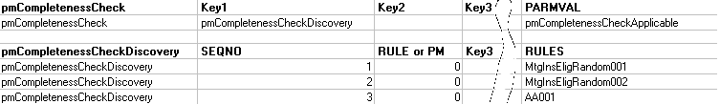
Completeness check rules are evaluated in Discovery mode. (See Discovery Mode Input on page 43.)

Parameter Matrix Data and Auto-Adjudication Rules
The set of rules run during auto-adjudication are the auto-adjudication rules. These can be rules that were defined in the Rules Designer, or custom rules. The auto-adjudication rules are arranged into categories depending on what function they serve in auto-adjudication.
Parameter matrix entries are created to match these categories of auto-adjudication rules. All auto-adjudication rules must be entered in one of the following Parameter Matrix entries:
- AA Application Status Rules
- AA Credit Risk Rules
- AA Critical Data Rules
- AA Eligibility Rules
- AA Insurance Critical Data Rules
- AA Insurance Eligibility Rules
- AA Insurance Routing Rules
- AA Score Cards Eligibility Rules
- AA Score Cards Rules
The value for each of these Parameter Matrix entries determines the rule or rule category that is run. Auto-adjudication rules are evaluated in Discovery mode. (See Discovery Mode Input on page 43.)
For the order in which these rules are run during auto-adjudication, see the Auto-Adjudication section in the Omiga OSS.

Parameter Matrix Data and Custom Rules
Custom rules can be run either during ingestion or during auto-adjudication. All custom rules must be entered in a Parameter Matrix entry titled pmUserRules. The COMPONENTTYPE key determines which service will run this rule.

Summary of Rules Run By Service
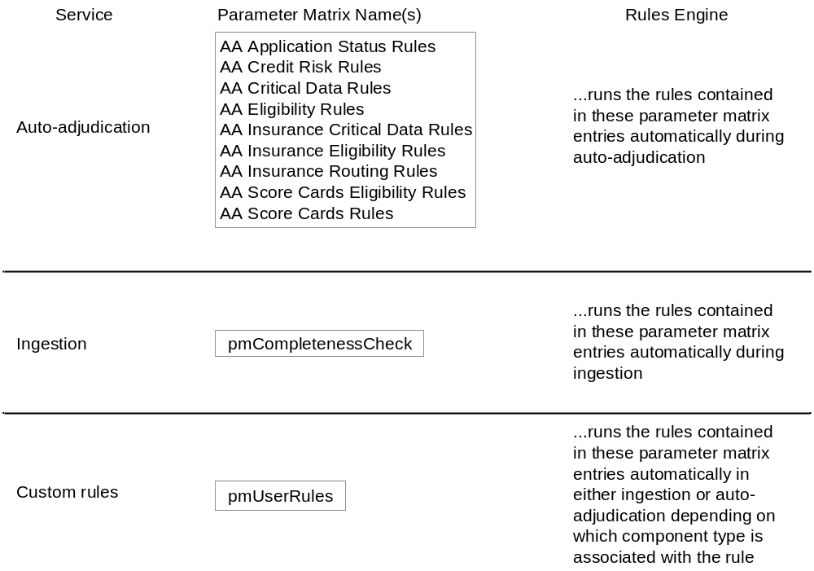
Figure 24: Rules Run By Service

Input Format
The following diagram summarizes the Rules Engine request model.
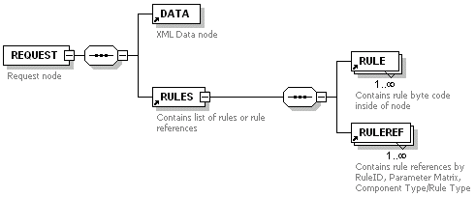
Figure 25: WSDL Schema: Rules Request

REQUEST Element
A REQUEST element contains the following attributes:
- LANGCODE
- OPERATION
- RE_ADD_KEYS
- RE_ADD_PASSED_RULES
- RE_ADD_RULENAME
- RE_ADD_CATEGORYNAME
Note: The attribute RE_ADD_CATEGORYNAME is only valid if the rule request is using a Parameter Matrix as a rule reference.
A REQUEST element contains the following elements:
- DATA
- RULES

Attributes
Attribute | Description
LANGCODE | The language code for this rule. En for English-based rules, Fr for French-based rules.
OPERATION | Currently, always set to PROCESS_RULES.
RE_ADD_KEYS | If set to 0, this attribute is ignored.  If set to 1, this attribute will add keys to the output when the Rules Engine processes the rule.
RE_ADD_PASSED_RULES | If set to 0, this attribute is ignored.  If set to 1, this attribute will add rules to the output when these rules have a Score of 0.
RE_ADD_RULENAME | If set to 0, the name of this rule is never added as an attribute to the output node.  If set to 1, the name of this rule is added as an attribute to the output node if the rule name attribute is specified as an output parameter or rule.  If set to 2, the name of this rule is always added as an attribute to the output node.
RE_ADD_CATEGORYNAME | If set to 0, this attribute is ignored.  If set to 1, this attribute will add the category name of this rule to the output when the Rules Engine processes the rule.

Elements
Element | Description
DATA | The XML data that is being passed in the current request to the Rules Engine from the Omiga database.
RULES | One of the following:  RULE  A set of XML rule logic entered directly in a BYTECODE element. See RULE Syntax on page 57.  RULEREF  An element which contains the following  - RULEID  - PM (Parameter matrix ID)  - COMPONENTTYPE  - RULETYPE

RULES Syntax
The RULES element contains the following elements:
- RULE
- RULEREF

Elements
Element | Description
RULE | A set of XML rule logic entered directly in a BYTECODE element. See RULE Syntax on page 57.
RULEREF | An element which contains the following  - RULEID  - PM (Parameter matrix ID)  - COMPONENTTYPE  - RULETYPE

RULE Syntax
A RULE element is composed of the following elements:
- BYTECODE
It contains the following attributes:
- ID
- RULETYPE
- NAME
- DESC

Attributes
Attribute | Description
ID | A unique identifier for this rule.
RULETYPE | The rule type for this rule. This is the same as the value obtained from the already existing corresponding database values in the Omiga database.
NAME | The name of this rule.
DESC | The description of this rule.

Elements
Element | Description
BYTECODE | The full XML representation of the business logic for this rule.

BYTECODE Syntax
The BYTECODE element contains the following attributes:
- ID
- CONTEXT
The BYTECODE element contains the following elements
- LOOP
- FILTER
- CONDITION
- OUTPUT

Attributes
Attribute | Description
ID | A unique identifier for this BYTECODE element.
CONTEXT | The current context where the Rules Engine will run the rule. It represents a pointer to a node in the underlying XML data set.

Elements
Element | Description
LOOP | Defines the element being used for the loop processing by the Rules Engine.
FILTER | Defines filtering rules for selectively working with the data from the underlying XML data set.
CONDITION | Defines condition rules for processing the data that has passed any filters.
OUTPUT | The types of output which result if the overall rule evaluates to true.

LOOP Syntax
LOOP elements contain the path (in XPath format) to the XML node being used as the loop. They contain the following elements:
- P (PATH)

Elements
Element | Description
P | Element containing the XPath expression to the node being used as the loop in the XML data file being evaluated by the rule.

P Syntax
The P element is empty and takes a single attribute, defining the XPath expression for the loop.

Attributes
Attribute | Description
V | The full XPath expression for the node being used as the loop in the XML data file being evaluated by the rule.

FILTER and CONDITION Syntax
FILTER and CONDITION elements can contain the following elements:
- AND

Elements
Element | Description
AND | Element that groups together all Boolean logic used to construct the rule (based on the required business logic). Analogous to a filter or condition group in the Supervisor GUI.

AND Syntax
The AND element can contain the following elements:
- B (BOOLEAN)

Elements
Element | Description
B | Element that contains individual Boolean logic.

B Syntax
The B element can contain the following elements:
- E (EQUALS)
The B element can contain the following attributes:
- T (TYPE)
The T attribute has a predefined set of values.

Attributes
Attribute | Description
T | The type of Boolean operation being performed on the data.

Enumerated Attributes
Enumerated Attribute | Description
EQ | The expression defined in the E child element of this B element is true if the two parameters in the expression are equal.
NE | The expression defined in the E child element of this B element is true if the two parameters in the expression are not equal.
IN | The expression defined in the E child element of this B element is true if the
NI
LT | The expression defined in the E child element of this B element is true if the first parameter in the expression is less than the second parameter.
LE | The expression defined in the E child element of this B element is true if the first parameter in the expression is less than or equal to the second parameter.
GT | The expression defined in the E child element of this B element is true if the first parameter in the expression is greater than the second parameter.
GE | The expression defined in the E child element of this B element is true if the first parameter in the expression is greater than or equal to the second parameter.

Elements
Element | Description
E | Contains the expression being used to test the data.

E Syntax
The E element contains the expressions used by the Rules Engine. These expressions are composed of:
- data retrieved from Omiga
- functions existing in Omiga
- constants entered as an attribute to the E element
The top E element represents the left side of the expression. The bottom E element represents the right side of the expression. For example, consider the following fragment of XML code.
<B T="EQ">
<E A="../@ADDRESSTYPE"/>
<E C="1"/>
</B>
This can be interpreted as "Parent of the attribute ADDRESSTYPE is equal to 1".
The E element can contain the following attributes:
- A (ATTRIBUTE)
- C (CONSTANT)
- F (FUNCTION)

Elements
Element | Description
A | Contains a reference to an attribute in the XML data set being processed.
C | Refers to a constant value.
F | Refers to an already existing function in the Omiga database.

OUTPUT Syntax
OUTPUT elements contain the following elements:
- AS
- M
- MIT
- Name
- Override
- S
- SID

Elements
Element | Description
AS | The status of the mortgage application being processed.
M | Message information returned if this rule evaluates to true.
MIT | The mortgage insurer type (for example, GE or CHMC).
Name | The name of this rule.
Override | An override value used with manual underwriting. If an underwriter has an authority value greater than this number, then they can approve a mortgage application that has been stopped in the auto-adjudication process. If they do not have an authority value greater than this number, then they must remove the mortgage application from the auto-adjudication process and work with the mortgage application manually.
S | The score returned if this rule evaluates to true.
SID | Each screen in the Omiga GUI has a screen ID associated with it. By entering the value of a screen ID in a rule, you can indicate where the user

RULEREF Syntax
A RULEREF element contains a reference to an existing rule in the Omiga database.
Note: At least one of the attributes from the ATTLIST must be included in this element.

Attributes
Attribute | Description
RULEID | The unique ID code for the rule.
PM | A unique Parameter Matrix ID. See Parameter Matrix on page 29.
COMPONENTTYPE | The component type for the rule.
RULETYPE | The rule type for the rule.

Sample Rule Requests
The following sample rule requests are provided to show how rules are built using XML.
Note: The string represents well-formed XML obtained from the application.

Rule Request using a RULE Node

Rule Request Using a <RULEREF> Node Referencing a Rule ID

Rule Request Using a <RULEREF> Node Referencing a Parameter Matrix
<REQUEST OPERATION="PROCESS_RULES">
<DATA>Application XML Payload</DATA>
<RULES>
<RULEREF PM = "pmRuleList1" />
</RULES>
</REQUEST>

Rule Request Using a <RULEREF> Node Referencing a Component Type/Rule Type
<REQUEST OPERATION="PROCESS_RULES">
<DATA>Application XML Payload</DATA>
<RULES>
<RULEREF COMPONENTTYPE = "12" RULETYPE = "1" />
</RULES>
</REQUEST>

Rule Request Using a <RULEREF> Node Referencing a Combination of Rule References
This example uses a combination of RULEID, Parameter Matrix (PM), and COMPONENTTYPE to reference the rule being used.
<REQUEST OPERATION="PROCESS_RULES">
<DATA>Application XML Payload</DATA>
<RULES>
<RULEREF COMPONENTTYPE = "12" RULETYPE = "1" />
<RULEREF RULEID= "101" />
<RULEREF PM = "pmRuleList1" />
</RULES>
</REQUEST>

Output
Rules ultimately will be delivered as an XML output. The Rules Engine is responsible for creating and formatting this output. The output is returned to the service which called it (for example, auto-adjudication or ingestion).
The content and structure of the output will vary depending upon which rule category was run, and which application data was being evaluated.

Components
The Rules Engine uses the following components:
- omRuleManager.dll: This contains the rules engine. This component processes incoming rules requests and creates rules output.

Relationship Diagrams
The Rules Engine passes XML-formatted messages and does not store information in the Omiga database.
        - RulesDescriptor.XML
RulesDescriptor.XML
For the latest version of the RulesDescriptor.XML file, see the Supervisor installation directory.
Index

A
about this document, 9
accessing functionality, 13
accessing record in category, 15
acronyms, 12
activity diagram, rules manager, 39
AND syntax, 59
applicability category, 38, 44
audience, 9
auto-adjudication rules, 53
B
B syntax, 59
book, who should read, 9
Boolean logic, 59
building custom rules, 37
business purpose
combo groups, 17
French data support, 25
parameter matrix, 29
rule designer, 32
rules engine, 52
rules manager, 38
BYTECODE syntax, 58
C
category, 14
accessing record in, 15
rules and, 46
COM Rule component, 51
combo groups, 17–20
business purpose, 17
components, 19
relationship diagrams, 20
Rule Designer and, 17
compiling, 37
components
combo groups, 19
parameter matrix, 30
rule designer, 37
rules engine, 64
rules manager, 51
creating new entry, 16
custom rules, 53
custom rules, building, 37
D
data support, French, 21–27
default language data, 26
relationship diagrams, 26
UI controls and, 22
database relationship diagrams. See relationship diagrams
default French language data, 26
designer, rules, 32–37
diagram, rules manager
activity, 39
discovery mode, 41
explicit mode, 41
dialog
Multilingual approve, 26
Parameter Matrix, 29
Rule Designer, 32
discovery mode, 38
example, 44
input, 42
output, 48
sequence diagram, 41
discovery_ruletype, 44
document
about this, 9
reference, 11
E
E syntax, 60
element, REQUEST, 55
engine, rules, 52–64
entries, Supervisor, 15, See also record
example, discovery mode, 44
explicit mode, 38
input, 49
output, 50
sequence diagram, 41
F
FILTER and CONDITION syntax, 59
flexibility in rules, 47
French
data support, 21–27
business purpose, 25
UI controls and, 22
French data support
default language data, 26
relationship diagrams, 26
French UI control, 25
functionality, accessing, 13
functions performed by Supervisor, 9
G
group name, 17
GUI. See UI
I
ingestion rules, 52
input
discovery mode, 42
explicit mode, 49
rules engine, 52
introduction, 9
L
language, French. See French
LOOP syntax, 58
M
manager, rules, 38–51
matrix, parameter, 29–31
mode
discovery. See discovery mode
explicit. See explicit mode
Multilingual approve dialog, 26
multilingual UI grid control, 25
N
new entry, creating, 16
nodes. See categories
O
omAppDataManger.dll, 51
Omiga services, rules and, 53
omParameterMatrix.dll, 51
omRuleManager.dll, 51, 64
omspvComboGroups.dll, 19
omspvPMatrix.dll, 31
omspvRuleDesigner.dll, 37
output
discovery mode, 48
explicit mode, 50
rule, 63
OUTPUT syntax, 61
overview of Supervisor, 13–16
P
P syntax, 59
Parameter Matrix, 29–31
business purpose, 29
components, 30
data
auto-adjudication rules, 53
custom rules, 53
ingestion rules, 52
relationship diagrams, 31
Parameter Matrix dialog, 29
pmCompletenessCheck, 54
pmUserRules, 54
purpose, business. See business purpose
R
RE_ADD_CATEGORYNAME, and validity, 55
record, accessing in category, 15
reference documents, 11
relationship diagrams
combo groups, 20
French data support, 26
parameter matrix, 31
rule designer, 37
rules engine, 64
rules manager, 51
request
model, Rules Engine, 54
rule, samples, 62
REQUEST element, 55
requirements, system, 9
rule
category and, 46
custom, building, 37
flexibility in, 47
output, 63
references, traversing, 48
run by service, 53
sample requests, 62
sequence numbers and, 48
Rule Designer, 32–37
business purpose, 32
combo groups and, 17
components, 37
relationship diagrams, 37
Rule Designer dialog, 32
RULE syntax, 57
RULEREF syntax, 62
Rules Engine, 52–64
business purpose, 52
components, 64
input, 52
relationship diagrams, 64
request model, 54
Rules Manager, 38–51
business purpose, 38
components, 51
diagram
activity, 39
discovery mode, 41
explicit mode, 41
relationship diagrams, 51
RulesDescriptor.xml, 33
S
sample rule requests, 62
Select Case, 37
sequence numbers, rules, 48
subjects in this document, 9
Supervisor
categories, 14
entries, 15
functions performed by, 9
overview, 13–16
syntax
AND, 59
B, 59
BYTECODE, 58
E, 60
FILTER and CONDITION, 59
LOOP, 58
OUTPUT, 61
P, 59
RULE, 57
RULEREF, 62
system requirements, 9
T
thick client, 13
traversing rule references, 48
U
UI control. See also dialog
multilingual, 25
V
validation type, 17
value ID/name pair, 17
W
who should read this book, 9
X
XSD schema
discovery mode input, 42
explicit mode input, 49

Figures List
Figure 1: Supervisor Main Window, highlighting the category described in this book. 13
Figure 2: Supervisor Categories. 14
Figure 3: Supervisor Entries 15
Figure 4: Add/Edit Combo Box Group dialog. 17
Figure 5: Combo Box Group Database Table Relationships 19
Figure 6: Multilingual Input Element 24
Figure 7: Multilingual Approve Message Box 25
Figure 8: Default French Language Values 25
Figure 9: Default English Language Values 25
Figure 10: Language Database Table Relationships 27
Figure 11: Parameter Matrix dialog. 29
Figure 12: Parameter Matrix Database Table Relationships 30
Figure 13: Rule Designer dialog. 31
Figure 14: Rule Designer Identification Pane 32
Figure 15: Rule Designer XML Context Pane. 33
Figure 16: Rules Designer Rules Builder Pane 34
Figure 17: Rules Designer File Operations Controls 35
Figure 18: Rules Designer Database Table Relationships 36
Figure 19: Rules Manager and Services 38
Figure 20: Rules Manager Activity Diagram 39
Figure 21: Discovery Mode Sequence Diagram 40
Figure 22: Explicit Mode Sequence Diagram 40
Figure 23: Categories and Rules Example 45
Figure 24: Rules Run By Service 52
Figure 25: WSDL Schema: Rules Request 53

